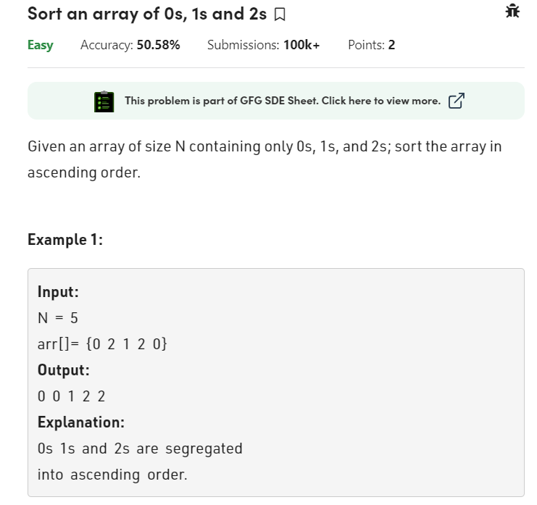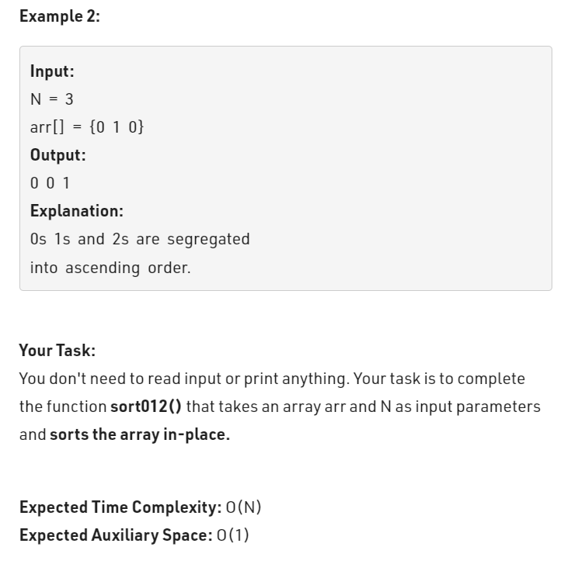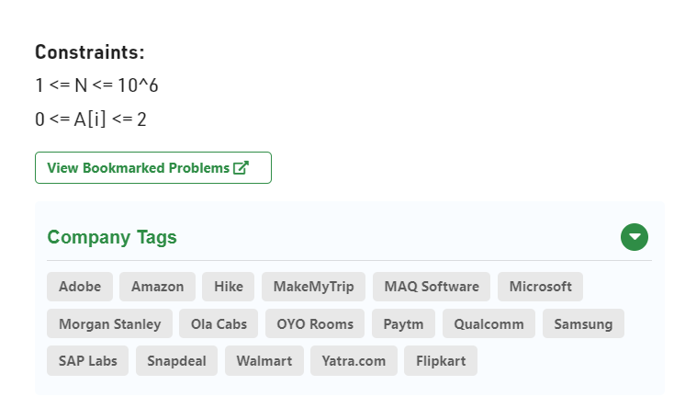

class Solution

{

public static void sort012(int a[], int n)

{

// code here

int start=0;

int mid = 0;

int end = n-1;

int temp;

while(mid <=end){

if(a[mid] == 0){

temp = a[mid];

a[mid] = a[start];

a[start] = temp;

start++;

mid++;

}

else if(a[mid] == 2){

temp = a[mid];

a[mid] = a[end];

a[end] = temp;

end--;

}

else if(a[mid] == 1){

mid++;

}

}

}

}